Thiruvalluvar College of Engineering And Technology

Arunachala city, ponnur hills, vandavasi-604 405

*Project title: ACRM Application To Manage The Ma****l***

Presented By:

Udhayakumar.N

(6C13843DF0ADAAB9F6C4573DE5826329)

Vaishnavi.K

(BC4C1A22EBDC55CAOBC4AFO9F3BA6EBB4)

Vasugi.V

(0832015DD515D1BA9714EC6F37F73322)

Suthish.R

(100654AA850A0B09A1040A6AFDBAF406)



A CRM Application To Manage the mall



A CRM ( Customer Relationship Management) application to

manage a mall is a software solution designed to improve

interactions with customers, tenants, and other stakeholders,

ultimately enhancing overall business operations and customer satisfaction . Here ’s an overview of how such an application could work :

*1. Customer Management*

Customer Profiles: Track detailed information about customers, including contact details, preferences, purchase history, and visit frequency.

Segmentation: Group customers based on , demographics, or interests for personalized marketing and promotions.

Communication Channels: Engage with customers via multiple channels like email, SMS, app notifications, and social media.

*2. Tenant/Store Management*

Tenant Profiles: Maintain records of all mall tenants, including store type, lease agreements, payment status, and contact details.

Lease Tracking: Keep track of lease expiration dates, renewals, and other contractual details to ensure smooth tenancy management.

Performance Monitoring: Collect sales data, foot traffic analytics, and customer feedback to assess each store’s performance and offer targeted support.

*3. Marketing and Promotions*

Campaign Management: Plan and execute targeted marketing campaigns based on customer segmentation, such as special offers, seasonal promotions, or loyalty

programs.

Event Management: Organize and track mall events, promotions, or sales with the ability to notify customers or tenants in real-time.



*4. Customer Service andSupport*

Helpdesk Integration: Provide a support portal for customers to ask questions, file complaints, or request assistance, with ticketing and tracking functionality.



Enhanced Customer Experience:

Personalized offers, targeted promotions, and timely customer service lead to greater satisfaction.

Improved Operational Efficiency:

Streamline processes related to tenant management, lease renewals, and customer engagement.

Increased Revenue:

By optimizing marketing strategies and tenant relations, the mall can drive more foot traffic and higher sales.

Data-Driven Decisions:

Use real-time data and analytics to make informed decisions on marketing, tenant management, and customer service .



Business goals:

The business goals of a CRM (Customer Relationship Management) application to manage a mall focus on improving customer satisfaction, enhancing operational efficiency, and maximizing revenue. Here are the key business goals:



Personalized Engagement: Tailor interactions with customers based on their

preferences, past purchases, and visit history, which improves satisfaction and loyalty

channel Communication: Provide seamless communication across multiple channels (email, SMS, mobile app, social media) to ensure customers receive timely updates and promotions.

Customer Support: Offer efficient, responsive customer service, addressing concerns or



inquiries quickly, leading to increased customer trust and retention.



Loyalty Programs: Implement and manage customer loyalty programs that incentivize repeat visits and purchases, enhancing lifetime customer value.

Targeted Promotions: Use customer segmentation to offer personalized discounts, events, or rewards that encourage return visits and higher spending.

Engagement Tracking: Track customer behaviour to identify high-value customers, creating opportunities for more meaningful engagement.



Key Deliverables:

1.*CUSTOMER DATABASE:* A centralized repository for storing customer data, including contact information, shopping behaviour preferences, and transaction history.

2.Customer Segmentation: Tools for segmenting customers based on demographics, purchase patterns, and engagement, enabling targeted marketing and personalized services.

3.Marketing Campaigns: Integration for creating and managing personalized

promotional campaigns, loyalty programs, and special offers tailored to specific customer groups.

4.Sales and Engagement Analytics: Dashboards and reports that track customer interactions, sales performance, foot traffic, and other key metrics.

5.Customer Support & Feedback System: A module for tracking customer inquiries, complaints, feedback, and resolution status.

*Outcomes:*

. Enhanced Customer Experience: A personalized shopping experience by

leveraging customer data, which leads to increased customer satisfaction and loyalty.

. Improved Marketing Effectiveness: Targeted marketing campaigns based on customer segments increase conversion rates and overall ROI on marketing spend.

. Increased Foot Traffic and Sales: Through personalized offers and promotions, the mall can attract more visitors, leading to higher in-store purchases.



 *enterdetails for sign up in Salesforce.*

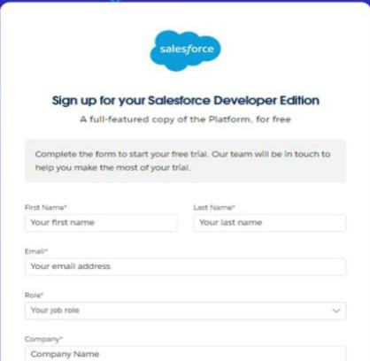



1. Salesforce Sales Cloud

Customer Data Management: Sales Cloud allows you to capture and organize customer information (e.g., shoppers, tenants, and other stakeholders) in one place. This includes contact details, preferences, and purchasing behaviour.

Lead and Opportunity Management: Manage potential tenants (stores) and customer inquiries by tracking leads and opportunities, ensuring that sales teams can convert leads into tenants and enhance tenant relationships.

Sales Pipeline Tracking: Monitor the status of leasing opportunities and manage negotiations with tenants, ensuring transparency and follow-up.

2. Salesforce Service Cloud

Customer Support and Case Management: Manage customer complaints or feedback



related to mall operations (e.g., maintenance issues, customer service inquiries, etc.). Service Cloud helps track and resolve issues efficiently.

Omni-Channel Support: Provide support across multiple channels (phone, email, chat, social media), enhancing customer experience for shoppers or tenants.

Knowledge Base: Build a self-service portal for tenants or shoppers, allowing them to access relevant FAQs, guides, and policies for quicker resolutions.

3. Salesforce Marketing Cloud

Customer Segmentation and Targeting: Use Marketing Cloud to segment customers

based on their behaviour and demographics. For example, create campaigns tailored to specific shopper groups or tenants (e.g., exclusive offers for high-value customers or seasonal promotions for tenants).

Email Campaigns and Automation: Automate marketing campaigns to send targeted offers, event invitations, or newsletters to shoppers and tenants. This can be used to drive foot traffic or promote mall events.

Social Media Engagement: Track and engage with *customerveri*on social media

platforms. You can run targeted campaigns to drive awareness or collect feedback.

*Goto the inbox ofthe emailthat usedwhile signing up. Clickon the*

*Verify account to activate your account.*

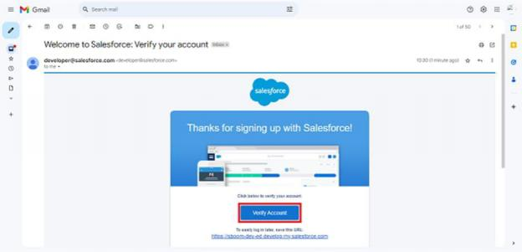

4.



Develop documentation of design:

1. Introduction

This document outlines the design and architecture of the CRM (Customer Relationship Management) application for managing a mall. The CRM system will enable mall

managers, stores, and tenants to effectively track customer interactions, enhance service offerings, improve marketing strategies, and foster better relationships with customers.

2. System Overview

The CRM application for mall management is designed to provide a unified platform for managing customer data, marketing campaigns, sales activities, customer service

requests, and more. The system will be used by mall management teams, individual store managers, and customer service representatives.

Key Features:

Customer Database: Store and manage customer information, including contact details, shopping preferences, and history.

Marketing Campaign Management: Create, track, and analyze marketing campaigns targeting different customer segments.

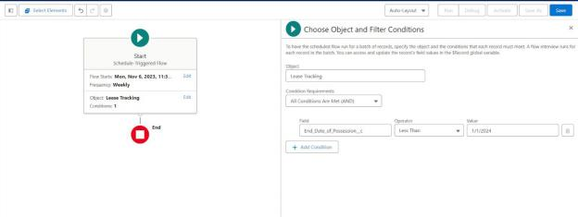

Encompassing data models:

The system will maintain the following entities and relationships:

. Customer

Attributes: Customer ID, First Name, Last Name, Email, Phone, Address, Date of Birth, Gender, Shopping Preferences, Loyalty Points, etc.

Relationships: One-to-many relationship with Sales, Events, and Campaigns.



. Sales

Attributes: Transaction ID, Date, Customer ID, Product(s) Purchased, Total Amount, Payment Method, Store ID, etc.

Relationships: Many-to-one relationship with Customer, many-to-one with Store.

. Store

Attributes: Store ID, Name, Category, Manager, Contact Details, etc.

Relationships: One-to-many relationship with Sales.

User interface and business logic:

User Interface (UI) Design

Overview

The UI of the CRM system for managing a mall should be user-friendly, responsive, and interactive, catering to various roles, such as mall administrators, store managers,

customer service .

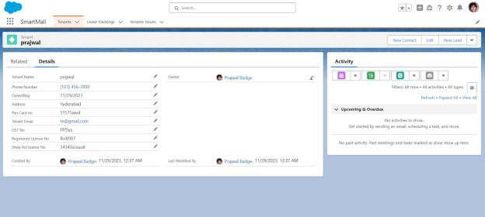



. Unit Testing:

Unit Testing Apex Classes

Overview of Unit Testing in Apex

Unit tests in Apex are written to verify that the business logic in the classes

behaves as expected. Salesforce requires that at least 75% of the Apex code is



covered by unit tests before deployment to production. Unit tests are written using the @isTest annotation and are executed in an isolated test context.

Example: Unit Test for Customer Management (Apex Class)

Scenario: We have an Apex class Manager responsible for creating new

customer records, updating loyalty points, and sending promotional emails.

interface testing

User Interface (UI) Testing for CRM Application in Mall Management

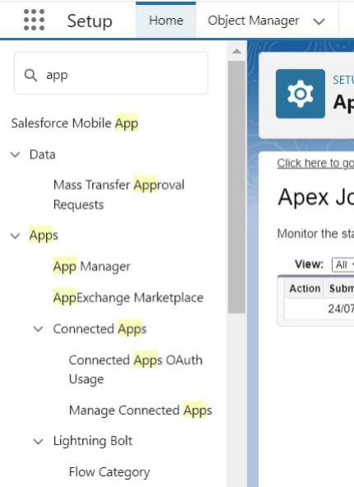

User Interface (UI) testing is crucial to ensure that the CRM application for mall



management is intuitive, functional, and responsive across various platforms. The goal is to verify that the UI components work as expected, provide a smooth user experience, and meet the business requirements.

Key Areas to Focus on for UI Testing

1 .Login & Authentication

Test the login screen for correct functionality (valid/invalid credentials, password recovery).

Verify session expiration and auto-logout functionality.

Check for security features (e.g., CAPTCHA, multi-factor authentication if applicable).

2.Navigation

Ensure the main navigation menu is clear and consistent (e.g., dashboards, tenant management, reports).

Test all links and buttons for correct redirects and interactions.

Check the responsiveness of the navigation on different screen sizes (desktop, mobile, tablet).

3.Dashboard

Test the layout of the dashboard. Ensure that key metrics and important actions (like sales data, occupancy rates, etc.) are displayed.





1. Customer Data Management

Scenario: Malls often have a large, diverse customer base, and managing customer data across various touch points (e.g., in-store, online, loyalty programs) can be a challenge.

Solution: Salesforce can centralize customer data, providing a 360-degree view of the customer. It allows mall management to track customer interactions, preferences, and behaviour, ensuring personalized communication and services.

2.Marketing Automation and Campaigns

Scenario: Mall managers need to target specific customer segments with tailored marketing campaigns to increase foot traffic and sales.

Solution: Salesforce’s marketing automation tools, such as Salesforce Marketing Cloud,



can help design and execute targeted email campaigns, promotions, and loyalty

rewards programs, helping to increase engagement with customers.

3. Tenant and Vendor Management

Scenario: A mall typically consists of multiple tenants (retailers, restaurants,

entertainment). Managing these relationships, tracking performance, and ensuring

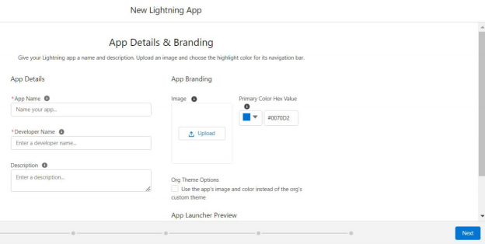

effective communication between mall management and tenants is complex.

Solution: Salesforce can be used to manage vendor relationships, track lease

agreements, monitor performance metrics (e.g., sales, customer footfall), and

streamline communication through a centralized platform.

4. Customer Service and Support

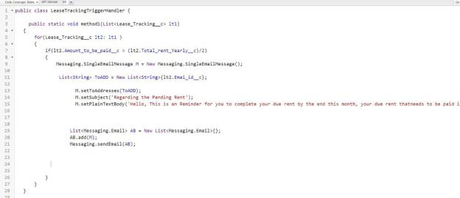



Scenario: Shoppers may have questions or issues related to mall services, events, or tenant products. Efficiently handling customer service requests is key to customer satisfaction.

Solution: Salesforce Service Cloud can help streamline customer service requests, offering support via multiple channels (email, chat, phone), tracking cases, and

providing self-service options through portals.

5. Sales and Revenue Tracking

Scenario: Mall management needs to track sales, monitor revenue streams from different tenants, and identify opportunities for growth.

Solution: Salesforce provides real-time reporting and dashboards that help mall

managers monitor sales and revenue performance by tenant, and track key metrics such as foot traffic, conversions, and sales per square foot.

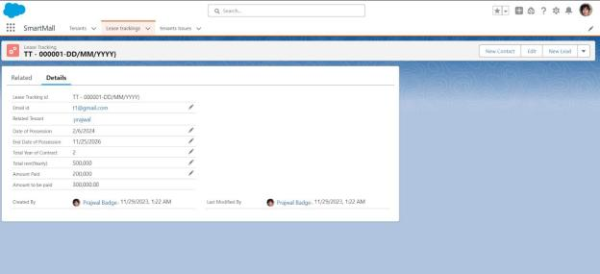

6. Event Management and Promotion

Scenario: Malls often host events (e.g., sales, exhibitions, festivals) to increase customer engagement. Coordinating these events can be complex, and tracking attendance and customer feedback is vital.

Solution: Salesforce can manage event registrations, track customer attendance, and

measure the success of events through engagement metrics, helping mall management improve future event strategies.

7. Analytics and Insights

Scenario: Mall management requires insights into customer behavior, sales trends, and operational performance to make data-driven decisions.



Solution: Salesforce’s analytics tools (e.g., Salesforce Einstein Analytics) can provide deep insights into customer data, sales trends, and mall performance, enabling

managers to optimize marketing efforts, improve tenant relations, and increase profitability.

8. Mobile Access and Field Operations

Scenario: Mall staff, security, and maintenance teams need access to data and customer interactions while on the move.

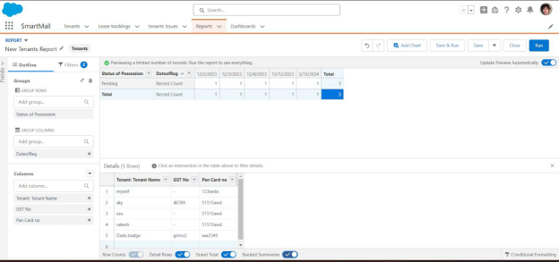

Solution: Salesforce’s mobile capabilities allow mall employees to access real-time

information, manage tasks, and update records from their smartphones, improving operational efficiency.

By implementing Salesforce in a mall management scenario, it becomes easier to manage customer relationships, streamline operations, and enhance the overall shopping experience for visitors, ultimately leading to better business outcomes.



In conclusion, a CRM (Customer Relationship Management) application for managing a mall can significantly enhance customer engagement, streamline operations, and

improve



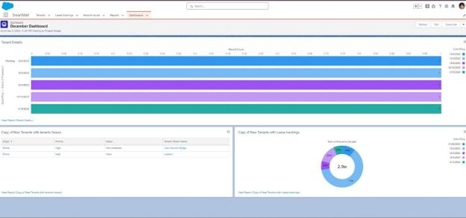

overall service delivery. By providing a centralized platform to track customer

preferences, purchase histories, and feedback, mall management can deliver

personalized experiences and targeted promotions. Additionally, CRM systems enable better communication between mall retailers, customers, and management, fostering loyalty and increasing sales. Overall, integrating a CRM system into mall management helps drive operational efficiency, boost customer satisfaction, and enhance business growth.



